Below is a screen capture ending Wednesday, November 16 at about 1:30 EST.

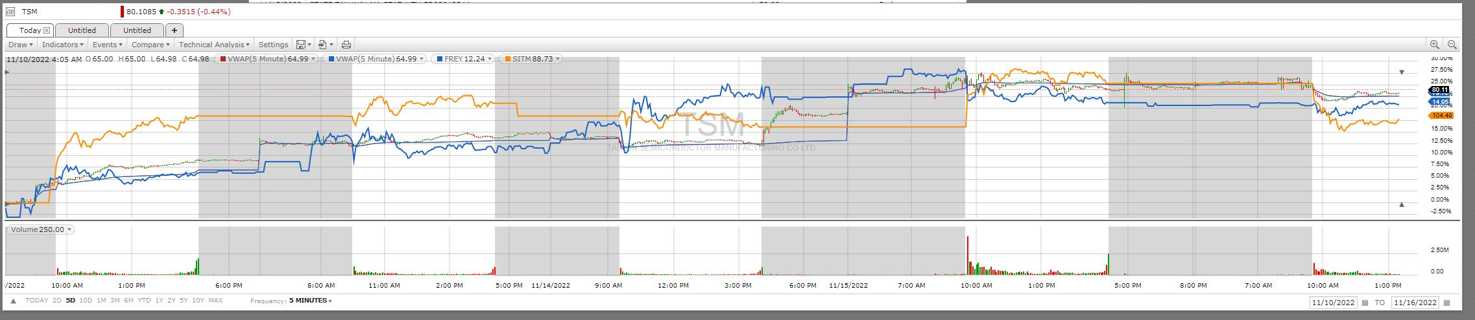

The 5 white blocs are the periods when the NYSE was open.

They are Thursday, Friday, Monday, Tuesday, and part of Wednesday.

Taiwan Semiconductor ADRs "TSM" are the subject of this chart and TSM's activity is the only activity that is shown conventionally

using green or red for every 5 minutes of activity.

As you can see, the other 4 items charted are FREY, SITH, VWAP5 and VWAP1. All 5 items charted are normalized into their own % change as shown by the chart at the right.

VWAP, Volume-Weighted Average Price, is calculated by totaling the dollars traded for every transaction

(price multiplied by the volume) and then dividing by the total shares traded. I am using two TSM VWAP time intervals: 1 minute and 5minute and

the two resulting charts pretty much completely overlap in position and color.

Now:

Using VWAP, we can speculate that Hathaway and maybe some other insider hangers-on are cleaning up last Thursday by offering a percent or two less, for

most of the shares being traded, than normal buyers thought they should reasonably offer. This continued into extended evening hours.

Overnight (imagine a left-right sliver of time on the chart) TSM's price changed from one relatively constant value to a (2 or 3%) higher value.

Note that if Hathaway was buying, it was no longer getting it for less than VWAP.

On Friday, we see that many morning and evening buyers continued to get shares at less than the ticker price.

On Monday, after hours EST, Hathaway (and others?) managed to do a lot of buying at a relatively fixed offer price.

But then things went crazy.

Note the high volume of trading Tuesday morning EST. It looks as if Hathaway was buying everything for sale at a relatively constant bid all day long!